SHEET CALCULATION BUTTON FOR SELECTING STOCK SHEETS

The SHT CALC button can be found in the estimating program at the bottom of the layout folder and also in the job file at the bottom of the material folder. Most often, the estimate is calculated with a generic estimated material such as 200C or SBS18 which has not defined sheet size in the raw materials file. The estimate program calculates the sheet size based on the style formulas and also adds trim waste from the machine file.

ASI recommends using the SHT CALC button in the job file to select a stocked sheet or a stocked roll size to issue to the production floor. Highlight the board material that you wish to replace with a stocked sheet or roll size. The system will only show material larger than the width and length for the job.

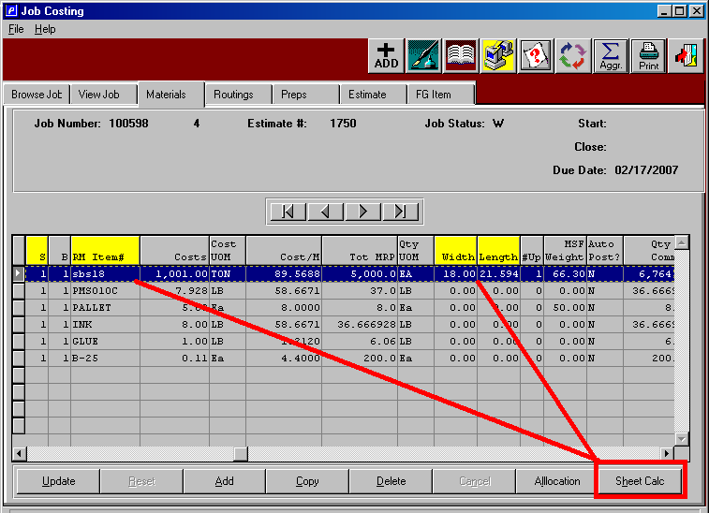

Sheet Calculation button displays popup window that allows you to select a machine and a board grade. Please note, you can press F1 on either field to select a machine or a material.

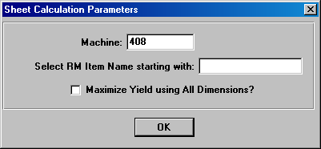

You will notice that the look up on the raw materials item will transfer the items name to back to the sheet calculation window. You may search by item code or by item name.

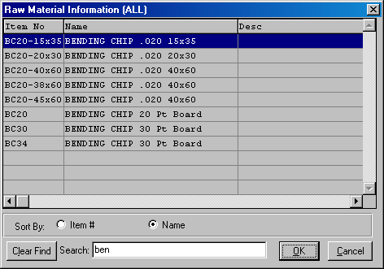

Notice, the item name is the field that is used to show you a list of possible material that may used for this job once I click the OK button. The list shows the material with the least amount of waste at the top.

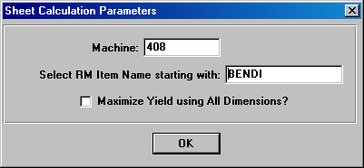

The screen below shows all the material that will run on the machine listed above and is large enough for the sheet size defined for the job. Please note, the job requires 5000 sheets, however our sheet which is the best fit has an insufficient number of sheets for the entire job. No problem, we can pick this sheet and then simply run the sheet calculation program again.

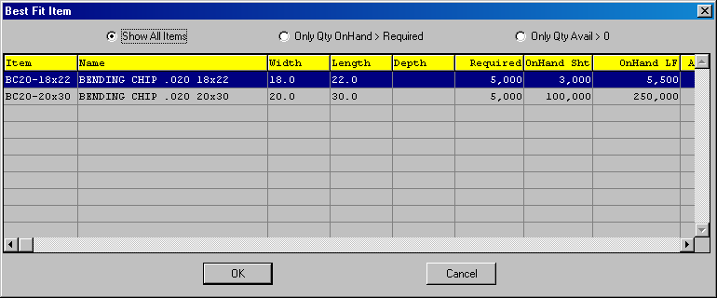

When the board material selected does not have enough on hand material, this message will appear just as a warning so that you may want to select another item that has enough on hand quantity to run the entire job. If you want to use the remaining balance of this time, simply click yes and the item will be added to the jobs material folder.

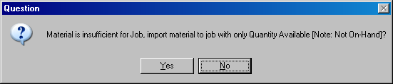

The board material selected may be immediately issued to the job, thereby eliminating the process of updating the job via the material issue process done via the M-U-2 menu key or done via sharp shooter. This option is controlled by the N-K-1 RMIssue logical value. If you do not want to issue the board, simply click NO.

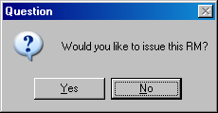

Once the board is selected, the material folder now houses the new sheet called BC20-18x22 for the full 3000 sheets on hand. However, please note that the original estimated material which was 5000 sheets has been reduced to 2000 sheets.
Therefore, the sheet calculation button should be press again to select another stocked material.

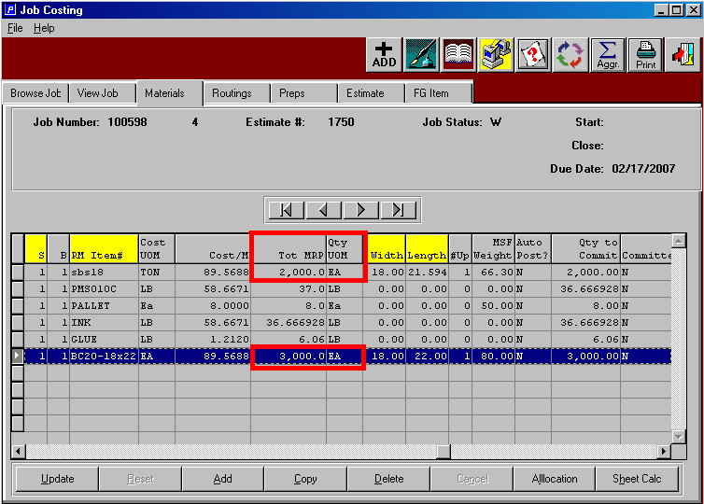

Once I select another board material, notice that both stocked sheets are not listed in the job file with the cost and sheets required properly updated. The new board material will be used in all job costing reports and will print on the jobs ticket.

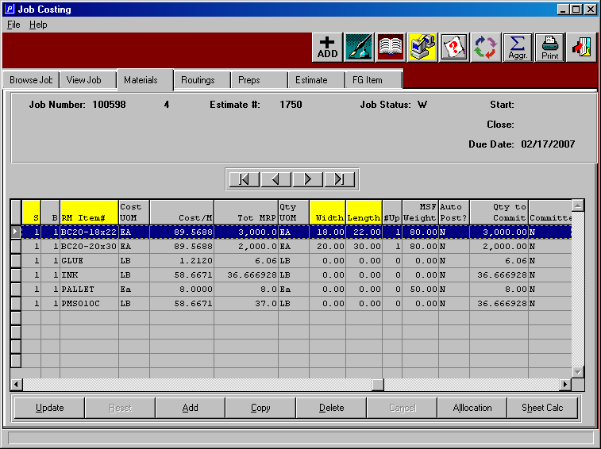

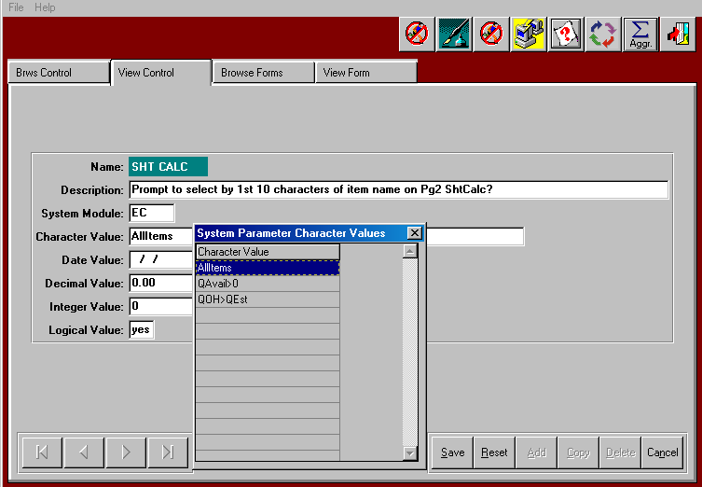

N-K-1 SHT CALC - This parameter controls the corrugated estimate and job file sheet calculation to determine the stocked sheet with the least waste.

Character value = All Items, the program will show all stocked sheets regardless of the quantity on hand, therefore normally stocked sheets, which are not on hand will still display on the inquiry.

Character value = QOH>QEst then the On Hand quantity must be greater than the estimated material required for the estimate quantity

Character Value = QAvail>0 will be used in Job File ShtCalc Button Columns show On Hand Shts, On Hand LF, Total Avail Shts, Total Avail LF. The total available sheets is calculated as available divided by sheet length. On Hand LF will be on hand sheets x job material length. Total available LF will be the available sheets x job material length.
When selecting the sheet calculation program on the job materials file, the program shows the materials that fit the existing sheet size. After selecting a roll or sheet, if the Total Available is less than boards MRP quantity, the system will prompt: "Material is insufficient for Job, import Material to job with only quantity available [Note: not on hand]?" Yes will import real board to job material file with quantity available. Answer NO to prompt will import item will MRP quantity. Either YES or NO will transfer the quantity on hand for that item to the MRP quantity and to the committed quantity. YES option will require selecting another stocked sheet or roll, hence the estimated board material will remain, however the MRP quantity will be reduced by the selected stocked boards MRP quantity transferred to the job file. Therefore, the planner may select another roll or sheet for the balance of the job. This process can continue until enough stocked sheets or rolls have been selected to fulfill the boards MRP quantity. Please note, the total MRP for all real board currently by sheet/blank (S/B) will update the 1st machines Run Qty on the job routing and will also print on the job ticket.

Please note, the sheet calculation button works with the parameter N-K-1 RMISSUE via the logical value = YES will automatically issue board to the job when selecting the board in the job file via the SHTCALC button. This is a problem for clients that use sharp shooter because this will not have a tag#, hence users of sharp shooter for raw materials should set the N-K-1 RMISSUE logical value to NO so they can issue board by scanning the tag numbers.

Logical value = YES, the program will prompt for the first three characters of item name to limit the search to specific board material. Therefore characters such as SBS would only show board material with the item names starting as SBS.

Logical Value = NO, the program will not prompt for the board material's first three letters, hence will not limit the search to a board type.

